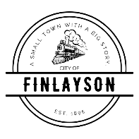
CITY COUNCIL
SPECIAL MEETING AGENDA
Monday, August 10, 2026 at 5:30 PM
FINLAYSON CITY HALL

- CALL TO ORDER - Pledge of Allegiance

- ROLL CALL
- REVIEW AND APPROVAL OF REZONING OF PARCEL ID 380085000 FROM AG TO RR
- ADJOURNMENT

